Dreadnought Tile Revit File import to user project file.
There is only one Revit model file (.rvt) that contains all the available Dreadnought Roof Tile Revit Family types in Revit 2016 format. Each family has full Meta data information (type parameters) related to a specific Dreadnought tile range.
The supplied Dreadnought Roof Tile BIM objects use the basic ‘Roof System Family’ and should be added to user’s projects as a system family. It is expected that these family objects will be added to a project by an experienced Revit user.
The suggested method for adding a Dreadnought Tile system family to a project is as follows:
- Open up the Revit project file into which the Dreadnought Tile family is to be copied.

- Open the downloaded Dreadnought Tile .RVT file and select the roof tile type you wish to transfer to your project file.

- On the ‘Modify’ ribbon, ‘Clipboard’ panel select the ‘Copy to Clipboard’ button. This will copy your single or multiple section to the computer clipboard (this can also be achieved using the standard Microsoft OS keyboard command ‘Ctrl+C’)
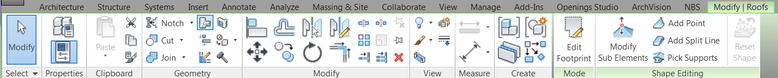

- Next move to the destination Revit project. On the ‘Modify’ ribbon, ‘Clipboard’ panel select the ‘Paste’ button to paste the previously selected roof tile family into the project. Click the left mouse button to place the roof family.
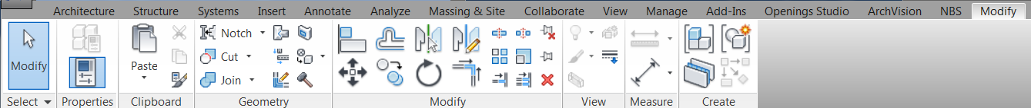

- Select and delete the placed roof family instance. The Dreadnought Tiles roof tile system family will now be available in the normal way that all system roof families are.
Parameters included in the Revit Dreadnought Tiles BIM Objects.
PARAMETER
Tile type Name >>
PARAMETER__________________
Construction
Structure
Default Thickness
Graphics
Course Scale Fill Pattern
Course Scale Fill Color
Analytical Properties
Heat Transfer Coefficient (U)
Thermal Resistance (R)
Thermal Mass
Absorptance
Roughness
Identity Data
Type Image
Keynote
Model
Manufacturer
Type Comments
URL
Description
Assembly Description
Assembly Code
Type Mark
Cost
IFC Parameters
AcousticRating
Combustible
Finish
FireRating
FlammabilityRating
FragilityRating
Material
Reference
SurfaceSpreadOfFlame
TotalThickness
IfcExportAs
IfcExportType
General
Author
BIMObjectName
ManufacturerName
ManufacturerURL
NBSDescription
NBSReference
NBSClauses
NBSNote
NBSOfficeMasterTag
NBSTypeID
ProductInformation
Revision
Uniclass2
Uniclass2015Description
Uniclass2015Reference
Uniclass2015Version
Version
Data
BattenSize
Profile
CoveringCapacity
Gauge
HeadLock
LinearCover
SizeOptions
InstalledWeight
MaximumGauge
MinimumPitch
SuitableFasteners
ColourOptions
EnvironmentalProductDeclaration
RecycledContent
TileHeadLap
Accessories
StandardsProductSpecification
StandardsMethodOfTest
PropertiesDurability
Other
AccessibilityPerformance
AssetType
Category
CodePerformance
Color
Constituents
DurationUnit
ExpectedLife
Features
Grade
ModelNumber
ModelReference
Name
NominalHeight
NominalLength
NominalWidth
ReplacementCost
Shape
Size
SustainabilityPerformance
WarrantyDescription
WarrantyDurationLabor
WarrantyDurationParts
WarrantyDurationUnit
WarrantyGuarantorLabor
WarrantyGuarantorParts

